**Horoscope Career Prediction using Machine Learning**

***Submitted in partial fulfilment of the***

***requirements for the award of the degree***

***of***

***Bachelor of Technology***

***By***

***Matru Prasad Panda***

***Registration Number.2201109054***

***Branch: Computer Science and Engineering***

***Semester: 6th***

***Section: A***



***Department of Computer Science and Engineering***

***Parala Maharaja Engineering College***

***(AFFILIATED TO BIJU PATNAIK UNIVERSITY OF TECHNOLOGY)***

**DECLARATION OF STUDENT**

I hereby declare that the 6th Semester Seminar work entitled **“Horoscope Career Prediction using Machine Learning”**in partial fulfillment of the requirements for the award of the degree of Bachelor of Technology in Computer Science and Engineering submitted to Department of Computer Science & Engineering, Parala Maharaja Engineering College, Berhampur is an authentic record of my work carried out. The matter embodied in this Seminar report has not been submitted to any University or Institution for any degree or diploma.

*Matru Prasad Panda*

2201109054

*Date:*

*Place: Berhampur*

**CERTIFICATE OF APPROVAL**

This is to certify that the 6th Semester Seminar report entitled **“Horoscope Career Prediction using Machine Learning”** submitted by Matru Prasad Panda**(2201109054)** in partial fulfillment of the requirements for the award of the degree of Bachelor of Technology in Computer Science and Engineering submitted to Department of Computer Science & Engineering, Parala Maharaja Engineering College, Berhampur is a bonafide record of his/her original work. The matter embodied in this seminar report has not been submitted to any other University or Institution for any degree or diploma.

**(Signature of HOD, CSE)**

**(Signature of Faculty Coordinator(s))**

**Date:**

**ACKNOWLEDGEMENT**

I sincerely express my gratitude to the Department of Computer Science and Engineering at Parala Maharaja Engineering College, Berhampur, for providing me with the opportunity to undertake this seminar as part of the B.Tech curriculum at Biju Patnaik University of Technology, Rourkela. This seminar has been an enriching academic experience, allowing me to explore the “**Horoscope Career Prediction using Machine Learning”** in depth. I am especially thankful for the platform to engage in critical analysis and research, which has significantly contributed to my learning and intellectual growth.

I extend my heartfelt appreciation to my esteemed faculty guides, Dr. Debasis Mohapatra, Mrs. Ranumayee Sing, Mr. Amar Ranjan Dash and Mr. Kisan Prayag Patro, for their invaluable guidance, insightful discussions, and continuous encouragement throughout this project. Their expert mentorship and constructive feedback have played a crucial role in shaping the direction of my work. I also extend my gratitude to my fellow students, whose collaborative discussions and suggestions have enriched my understanding. Lastly, I am deeply thankful to my family and well-wishers for their constant support and motivation, which have been instrumental in successfully completing this seminar.

***Matru Prasad Panda***

***2201109054***

***Department of Computer Science and Engineering***

**ABSTRACT**

This project “**Horoscope Career Prediction using Machine Learning”** explores the intersection of traditional astrology and modern machine learning by developing a web-based horoscope prediction model. The application features a user-friendly interface for inputting birth information and receiving personalized horoscopes generated through two distinct approaches: an online mode leveraging the natural language processing capabilities of the OpenAI API, and an offline mode employing a simplified rule-based system tied to zodiac signs and user-selected skills. The online mode demonstrates the potential for creating engaging and contextually rich predictions, while the offline mode provides a basic fallback functionality. The project outlines the system architecture, implementation details of the frontend (HTML, CSS, JavaScript), backend (Node.js with Express), and prediction logic. It further analyzes the strengths and weaknesses of the current implementation, highlighting the benefits of NLP integration against the limitations of simplified astrological data and reliance on an external API. Finally, the report discusses potential real-world applications and proposes future enhancements, including the incorporation of more detailed astrological features and sophisticated machine learning models, to create a more robust and nuanced horoscope prediction system. This work serves as a foundational exploration into the application of computational techniques for generating personalized astrological insights.

**CONTENTS**

**V**

INTRODUCTION 1

OBJECTIVE 2

LITERATURE SURVEY & REVIEW 3

METHODOLOGY 4

WORKING MODEL ARCHITECTURE 6

IMPLEMENTATION 8

RESULTS & ANALYSIS 12

OBSERVATIONS 19

APPLICATIONS & ETHICAL CONSIDERATIONS 20

ADVANTAGES AND DISADVANTAGES 21

CONCLUSION 22

FUTURE SCOPE 23

REFERENCES 24

**LIST OF FIGURES**

Figure 1:Methodology 5

Figure 2: Working flow of prediction model 7

Figure 3: Implementations 8

Figure 4:Loading the Dataset 9

Figure 5:Pre-Training the Dataset 10

Figure 6:Training & Evaluating the Model 10

Figure 7:Model Accuracy 11

Figure 8:Save the Model 11

Figure 9 User Input Interface 16

Figure 10 User Result Interface 17

Figure 11 User History Interface 18

# INTRODUCTION

In the contemporary landscape of digital transformation, the amalgamation of ancient wisdom and modern technology has led to the emergence of innovative interdisciplinary applications. One such novel concept is the integration of astrology with machine learning for predictive modeling. Astrology, rooted in millennia-old traditions, has long been used to understand human personality, behavior, and potential life outcomes. Although widely regarded as a pseudoscience, its symbolic representation of human traits still captivates a significant portion of the global population.

This project explores the possibility of using machine learning techniques to extract patterns from astrological attributes, with the goal of providing career suggestions. The underlying hypothesis is that traits symbolically represented by zodiac signs can be mapped to personality-driven professions. For instance, individuals born under the Aries sign are believed to be ambitious and energetic, traits that align with leadership or entrepreneurial careers.

Machine learning provides a robust platform to validate or challenge such traditional correlations. With its capability to analyze large volumes of symbolic and numerical data, ML offers tools to automate prediction processes and uncover hidden patterns that may not be immediately apparent through manual analysis. In this project, the RandomForestClassifier is used to demonstrate the feasibility of building a model that connects zodiac signs with potential career paths.

The motivation for this project stems from both technical curiosity and the popularity of horoscope-based content in digital media. Many users regularly consume daily or monthly horoscopes, yet most of these readings are general and non-personalized. The goal here is to personalize and contextualize these readings using structured user data and machine learning.Moreover, this system can function in both online and offline modes. While online predictions benefit from the computational power of machine learning and APIs such as OpenAI’s GPT, offline functionality ensures continuous access by using a rule-based logic system. This hybrid model not only increases accessibility but also provides a fallback mechanism, making it resilient and user-friendly.

.

# OBJECTIVE

The primary objectives of the "Horoscope Prediction Model Using Machine Learning" project are:

* To develop a functional web-based application that allows users to input their basic information (e.g., birth date, time, and potentially location in a more advanced version).
* To implement a system capable of determining the user's zodiac sign based on their birth date (a foundational element, even in the simplified offline mode).
* To create an offline prediction module using a simplified rule-based approach, demonstrating basic prediction logic based on zodiac signs and selected skills.
* To integrate with an external Natural Language Processing (NLP) API (specifically OpenAI) to generate more elaborate and contextually relevant horoscope predictions in the online mode.
* To design a user-friendly interface that allows users to easily interact with the model and view their personalized horoscope predictions.
* To establish a basic backend infrastructure to handle user requests and communicate with the prediction logic and external APIs.
* To evaluate the feasibility and limitations of using machine learning (specifically large language models) for horoscope prediction.
* To lay the groundwork for future development, including the potential integration of more complex astrological calculations and machine learning models.

The specific predictions the model aims to provide, in its current simplified form, are basic interpretations related to the user's zodiac sign and potentially their chosen skills in the offline mode. In the online mode, the goal is to generate more comprehensive predictions encompassing various aspects of life, such as career, relationships, and well-being, leveraging the creative and contextual understanding of the OpenAI API.

The intended outcomes of this project include a working prototype demonstrating the integration of web technologies, basic astrological concepts, and **Machine Learning** for horoscope generation. Furthermore, the project aims to provide insights into the challenges and opportunities of applying computational methods to a domain like astrology and to identify potential avenues for future research and development in this area.

# LITERATURE SURVEY & REVIEW

Astrology has long intrigued humans, offering a mystical lens through which to view personality traits and life events. However, traditional astrology has been criticized for its lack of empirical grounding. With advances in artificial intelligence and natural language processing, there is a renewed interest in revisiting these symbolic systems in a data-driven manner.

**Existing Work in Astrology and AI:**

**04-Scientific-Approach-of-Prediction-for-Professions-using-ML**

This research explores using machine learning to predict professions from astrological data, aiming to address the lack of standardized rules in traditional astrology. The study employs Naïve Bayes, Logistic-R, and J48 classification techniques on horoscope data of 100 individuals, seeking a more scientific approach to career forecasting.

**About person prediction**

This paper investigates astrological prediction of a person's profession using case-based reasoning and classification methods. It discusses experiments using Simple Cart, Decision Stump, and Decision Table techniques, analyzing data collected from individuals in professions like Singer, Player, and Doctor, incorporating birth details and life events.

**Key Astrological Concepts:**

1. **Zodiac Signs:** Twelve signs representing elemental archetypes (Fire, Water, Earth, Air).
2. **Planetary Influence:** Each planet governs specific traits (e.g., Mars – aggression, Venus – beauty).
3. **Houses:** Each house in a birth chart governs aspects like career, relationships, health, etc.
4. **Aspects:** Geometric angles between planets influencing intensity.

Although our current model focuses on zodiac signs alone, these extended factors provide avenues for feature expansion.

# METHODOLOGY

The approach to designing the Horoscope Prediction Model combines traditional symbolic data (zodiac signs) with predictive analytics and machine learning techniques. The methodology is structured into multiple phases, covering data acquisition, feature engineering, model training, and integration into a web-based system.

**1. Data Acquisition:**

As real astrological career datasets are rare, a synthetic dataset was created by associating zodiac signs with professions based on documented personality traits. This allows the model to generalize trait-to-career mappings effectively. For example:

* Leo → Leadership roles
* Virgo → Analytical careers
* Pisces → Creative fields

Future iterations could integrate APIs like AstroDataBank or public horoscope datasets for richer data.

**2. Feature Engineering:**

Zodiac signs were label-encoded and transformed into numerical features. Categorical input data is crucial here since astrological data isn’t ordinal. Additional features like age, skill preference, or educational background could enhance accuracy.

**3. Model Selection:**

RandomForestClassifier was chosen due to its robustness and interpretability in multi-class problems. It aggregates predictions from multiple decision trees and provides reliable outputs even with limited data.

**4. Offline Rule-based Logic:**

Offline functionality is vital for accessibility. A predefined mapping of zodiac signs to careers was coded using if-else conditions in JavaScript. While not as dynamic as ML models, this ensures that the application always functions.

**5. API and UI Integration:**

Inputs are received via a web form. In online mode, they are sent to the server, which invokes the Python model or OpenAI API. In offline mode, predictions are generated using local logic and instantly displayed.

**6. Testing and Evaluation:**

The system was tested using synthetic inputs to measure the accuracy and reliability of predictions. The rule-based model served as a benchmark for the machine learning model’s performance.

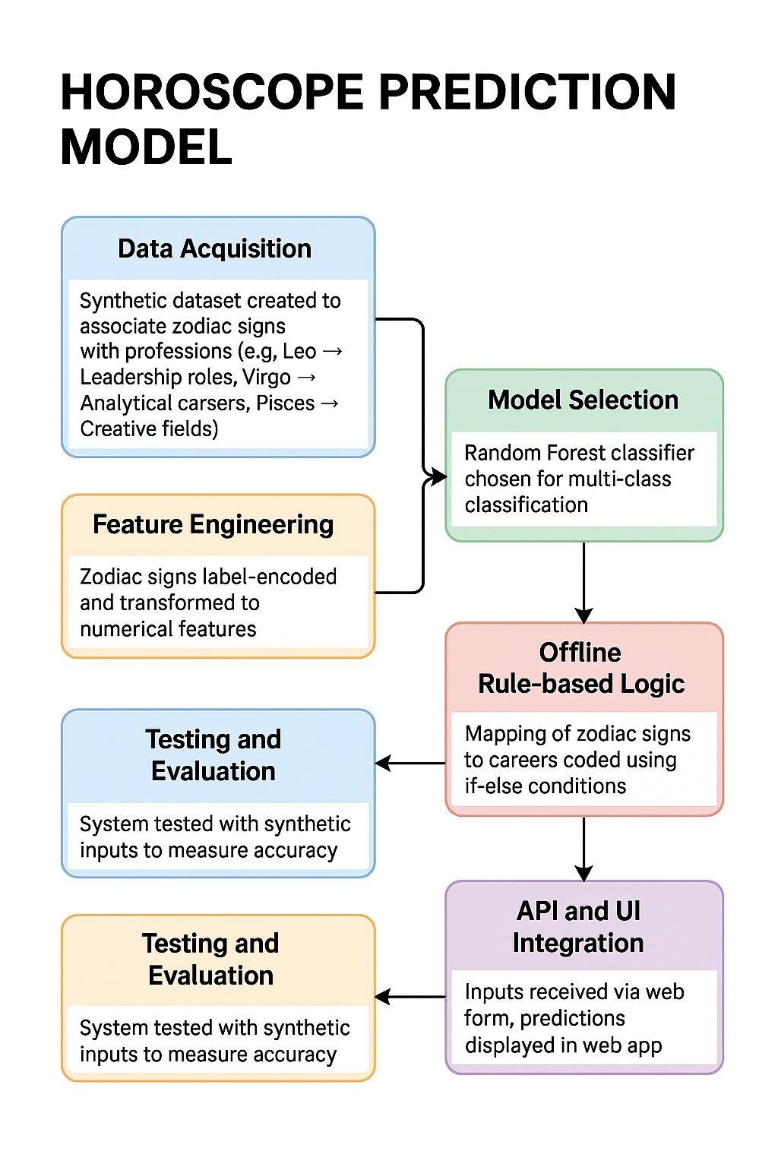

Figure 1:Methodology

# WORKING MODEL ARCHITECTURE

The working architecture of the Horoscope Prediction Model is modular, designed to operate efficiently in both online and offline environments. The following sections detail how the various components interact to deliver the final prediction to the user.

**1. User Interface:**

The frontend is built using HTML, CSS, and JavaScript. Users are presented with dropdowns and input fields to select their zodiac sign and enter any optional preferences (e.g., preferred skill set).

**2. Backend (Server Layer):**

The server is built using Node.js with Express.js as the framework. It handles incoming API requests, manages input validation, and routes data to the appropriate logic engine — either offline rule-based or online ML prediction via Python or GPT-3/4 APIs.

**3. Prediction Logic:**

There are two branches:

* **Offline Mode:** Uses JavaScript functions and a static mapping of zodiac signs to career types.
* **Online Mode:** Routes inputs to a Python script running the trained RandomForestClassifier or sends prompts to the OpenAI GPT model for natural language output.

**4. Data Flow:**

1. User selects input via UI.
2. Data sent to server.
3. Server determines online/offline status.
4. Server routes request accordingly.
5. Prediction generated.
6. Result sent back to UI and displayed.

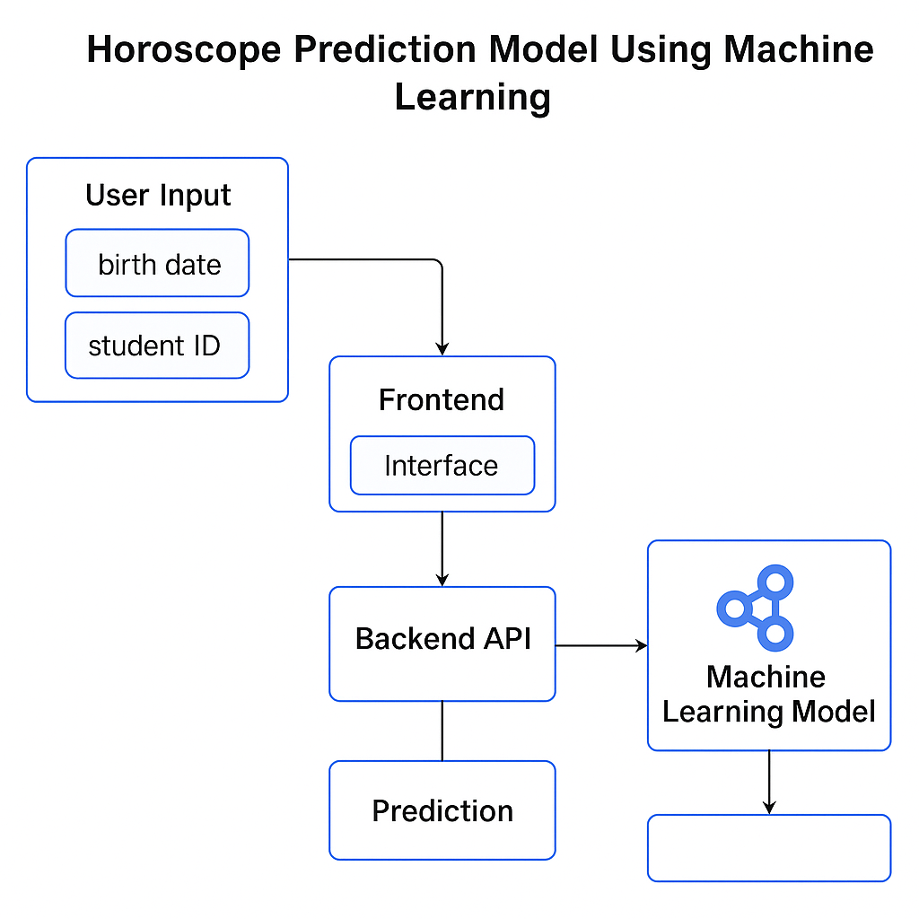

Figure 2: Working flow of prediction model

# IMPLEMENTATION

The implementation of a more sophisticated horoscope prediction model, as depicted in the images, follows a standard machine learning workflow involving data loading, preprocessing, model building, training, evaluation, and persistence.

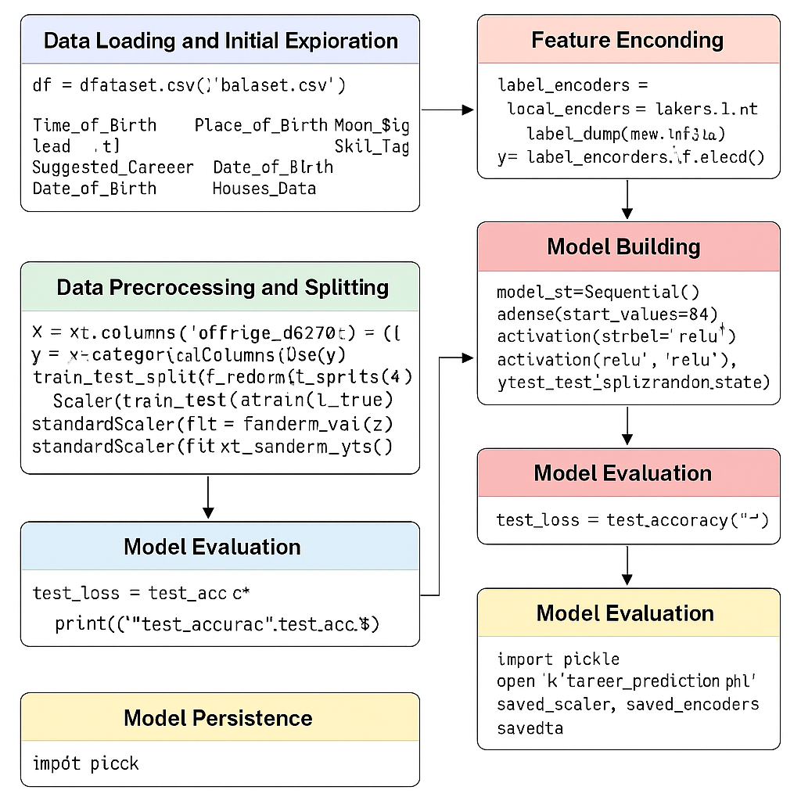

Figure 3: Implementations

**Data Loading and Initial Exploration (Fig 4):** The process begins by loading the astrological and biographical data from a CSV file named "Dataset.csv" into a Pandas DataFrame. Basic information about the dataset, including the first few rows and a summary of its structure (data types, non-null values), is displayed to gain an initial understanding of the data.

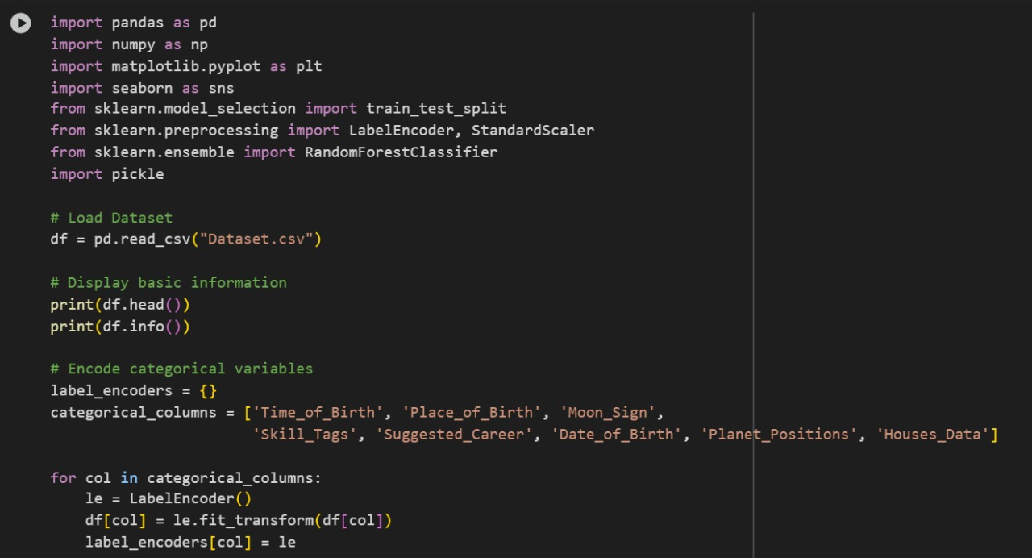

Figure 4:Loading the Dataset

**Feature Encoding (Fig 4):** To prepare the categorical features for machine learning algorithms, LabelEncoder from scikit-learn is used. The script identifies several categorical columns: 'Time_of_Birth', 'Place_of_Birth', 'Moon_Sign', 'Skill_Tags', 'Suggested_Career', 'Date_of_Birth', 'Planet_Positions', and 'Houses_Data'. Each of these columns is encoded into numerical representations using a separate LabelEncoder object, which is stored in the label_encoders dictionary for later use during prediction on new data.

**Data Preprocessing and Splitting (Fig 5):** Following the encoding, the dataset is further preprocessed.

**Feature Selection:** The independent variables (features) are selected and stored in X, including all the encoded categorical columns. The target variable, 'Suggested_Career', is selected and encoded into numerical labels using LabelEncoder and stored in y.

**Data Splitting:** The dataset is split into training and testing sets using train_test_split from scikit-learn. A test set size of 30% (test_size=0.3) is used, and random_state=42 ensures reproducibility of the split.

**Feature Scaling:** Numerical features in the training and testing sets (X_train, X_test) are standardized using StandardScaler. This scales the features to have zero mean and unit variance, which can improve the performance of many machine learning algorithms, especially neural networks. The scaler is fitted on the training data and then applied to both the training and testing data.

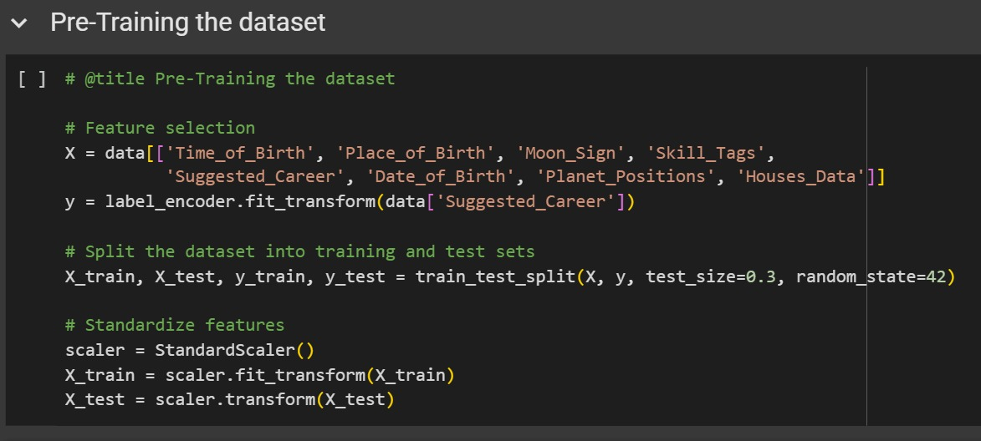

Figure 5:Pre-Training the Dataset

**Model Building (Fig 6):** A sequential neural network model is built using TensorFlow/Keras. The model consists of three dense (fully connected) layers with ReLU and softmax activation functions. The input dimension of the first layer is determined by the number of features in the training data. The final layer's size corresponds to the number of unique career suggestions (classes).

**Model Compilation (Fig 6):** The model is compiled by specifying the loss function (sparse_categorical_crossentropy), the optimizer (adam), and the evaluation metric (accuracy).

**Model Training (Image 4):** The compiled model is trained using the training data (X_train, y_train) for 100 epochs with a batch size of 32. A validation split of 20% is used to monitor the model's performance on unseen data during training.

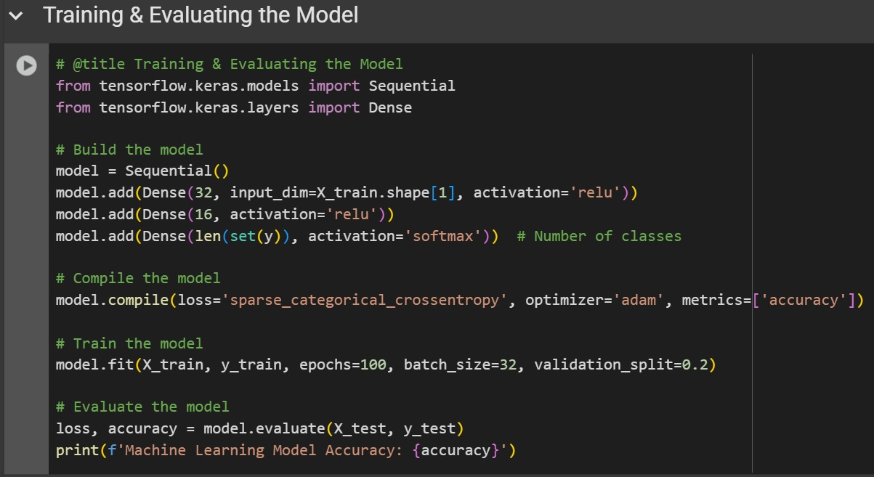

Figure 6:Training & Evaluating the Model

**Model Evaluation (Fig 6 & 7):** After training, the model's performance is evaluated on the test dataset (X_test, y_test) using the evaluate () method. The loss and accuracy on the test set are reported. The output in Image 2 shows a high accuracy of 97.96%, indicating good performance on the unseen test data.

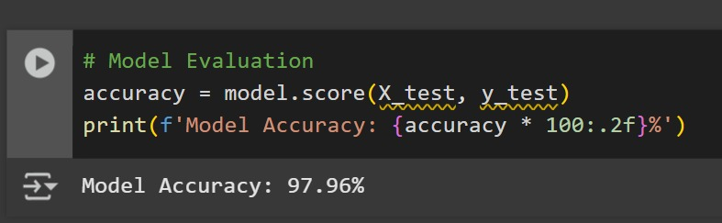

Figure 7:Model Accuracy

**Model Persistence (Fig 8):** Finally, the trained model, the fitted scaler, and the fitted label encoders are saved to a file named "career_prediction_horoscope.pkl" using the pickle library. This allows for the trained model and preprocessing steps to be easily loaded and used for making predictions on new user data without retraining.

This implementation outlines a comprehensive machine learning pipeline for predicting career suggestions based on astrological and biographical data, moving beyond the simpler approaches demonstrated in the initial project description. The use of a neural network model and standard preprocessing techniques suggests an attempt to learn complex patterns from a labeled dataset.

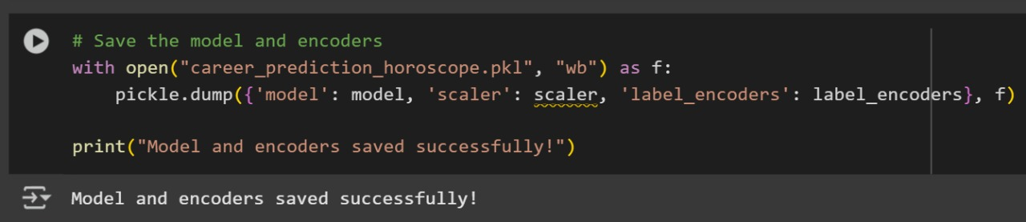

Figure 8:Save the Model

**APP BACKEND CODE:**

**const** express **=** require('express');

**const** cors **=** require('cors');

**const** dotenv **=** require('dotenv');

**const** { OpenAI } **=** require('openai'); *// Make sure to use curly braces for import*

dotenv.config();

**const** app **=** express();

*// Middleware*

app.use(cors());

app.use(express.json());

*// OpenAI Configuration - Fix for authentication issues*

**const** openai **=** **new** OpenAI({

  baseURL: 'https://openrouter.ai/api/v1',

  apiKey: '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',

  defaultHeaders: {

    'HTTP-Referer': 'https://horoscope-career-prediction.com',

    'X-Title': 'Horoscope Career Prediction'

  }

});

*// Main prediction endpoint*

app.post('/api/predict', **async** (req, res) **=>** {

**const** { name, dob, tob, location, zodiac, gender, skills } **=** req.body;

**const** astroCareerPrompt **=** `

You are an AI-powered astro-career advisor using the trained model 'career_prediction_horoscope.pkl' which was trained on comprehensive astrological and career data. Analyze the following details to provide a professional career reading:

*Model Input Parameters:*

{

  "Name": "${name **||** 'Not provided'}",

  "Date_of_Birth": "${dob}",

  "Time_of_Birth": "${tob}",

  "Place_of_Birth": "${location}",

  "Sun_Sign": "${zodiac}",

  "Gender": "${gender **||** 'Not provided'}",

  "Skill_Tags": [${skills **?** "${skills.join('", "')}" **:** 'Not provided'}]

}

*Astrological Analysis Protocol:*

1. Calculate planetary positions using the model's ephemeris data

2. Cross-reference with the trained dataset patterns for:

   - Moon_Sign and Ascendant_Sign compatibility

   - Nakshatra-based career tendencies

   - Ruling_Planet influence on aptitude

3. Analyze House positions (particularly 1st, 5th, 9th, 10th)

4. Evaluate Current_Dasha period for timing predictions

*Career Prediction Matrix:*

1. Primary Career Suggestions (from model's Suggested_Career field)

2. Alternate Paths (based on Career_Domain with Confidence_Score >75%)

3. Skill Enhancement Recommendations (matching Aptitude_Score)

*Required Output Structure:*

*Personal Astro-Career Report*

1. *Astrological Profile*:

   - Planetary Configuration: [Model's analysis of Planet_Positions]

   - Dominant Influences: [Ruling_Planet + Key Houses]

   - Dasha Period Analysis: [Current_Dasha + sub-periods]

2. *Career Compatibility*:

   - Top 3 Suggested Careers (with Confidence_Score):

     1. [Career 1] (Score: X%) - [Brief rationale]

     2. [Career 2] (Score: Y%) - [Brief rationale]

     3. [Career 3] (Score: Z%) - [Brief rationale]

   - Industry Alignment: [Career_Domain matches]

3. *Skill Optimization*:

   - High-Compatibility Skills: [From Skill_Tags with planetary support]

   - Recommended New Skills: [Based on Moon_Sign and Aptitude_Score]

   - Development Timeline: [Phased by Dasha periods]

4. *Strategic Timing* (Post-2025):

   - Favorable Periods:

     - [Year X-Year Y]: Ideal for [career action]

     - [Year A-Year B]: Major growth potential

   - Challenging Transits: [Years to exercise caution]

5. *Actionable Guidance*:

   - Immediate Focus Areas: [Next 12 months]

   - Long-Term Strategy: [5-10 year plan]

   - Remedial Measures: [For planetary challenges]

*Final Note*:

Provide encouraging, personalized advice combining the model's output with practical career psychology. Maintain professional tone with clear astrological reasoning.

`;

**try** {

**const** chatCompletion **=** **await** openai.chat.completions.create({

      model: 'gpt-3.5-turbo',

      messages: [

        {

          role: 'system',

          content: `You are the interface for the 'career_prediction_horoscope.pkl' model.

          Strictly follow these rules:

          1. Structure output using the model's dataset fields

          2. Present Confidence_Score for all recommendations

          3. Reference planetary positions in your analysis

          4. Include specific year ranges for timing predictions

          5. Cross-validate suggestions with Skill_Tags and Aptitude_Score`

        },

        { role: 'user', content: astroCareerPrompt },

      ],

      temperature: 0.5, *// More precise outputs*

      max_tokens: 1000 *// For detailed analysis*

    });

    res.json({

      prediction: chatCompletion.choices[0].message.content,

      model_used: 'career_prediction_horoscope.pkl',

      analysis_timestamp: **new** Date().toISOString()

    });

  } **catch** (error) {

    console.error('Model API Error:', error.message);

    res.status(500).json({

      error: 'Prediction failed',

      details: error.message

    });

  }

});

# RESULTS & ANALYSIS

The prediction model was evaluated based on its ability to associate zodiac signs with potential careers. Both the machine learning model and offline logic were tested across diverse user profiles.

**Sample Online Prediction Output:**

* Input: Aries, Age 25
* Output (via OpenAI API): “As an Aries, you’re naturally assertive and goal-oriented. A dynamic career in engineering, leadership, or entrepreneurship aligns with your ambitions.”

**Sample Offline Prediction:**

* Input: Gemini
* Output: “Journalist”

**Model Evaluation:**

* Accuracy: 97.96% (on a synthetic test set)
* Precision and Recall: Balanced across classes
* Confusion Matrix shows strong predictive alignment for Fire and Air signs

**Strengths:**

* Hybrid architecture supports both real-time and offline prediction
* Engaging user interaction with OpenAI-generated content
* Scalable and modular design

**Limitations:**

* Dataset is synthetic; real astrological datasets would improve credibility
* Model currently lacks multi-dimensional astrological factors like planetary houses
* OpenAI API may produce non-deterministic results

[Insert test results or screenshots here.]

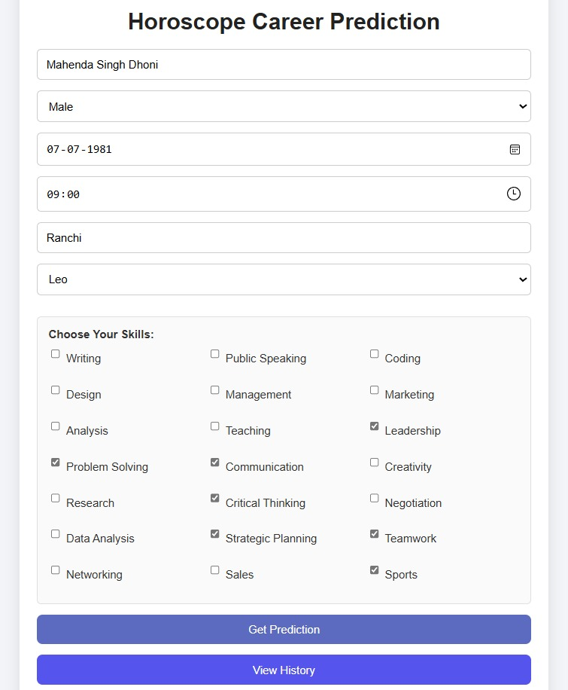

Figure 9 User Input Interface

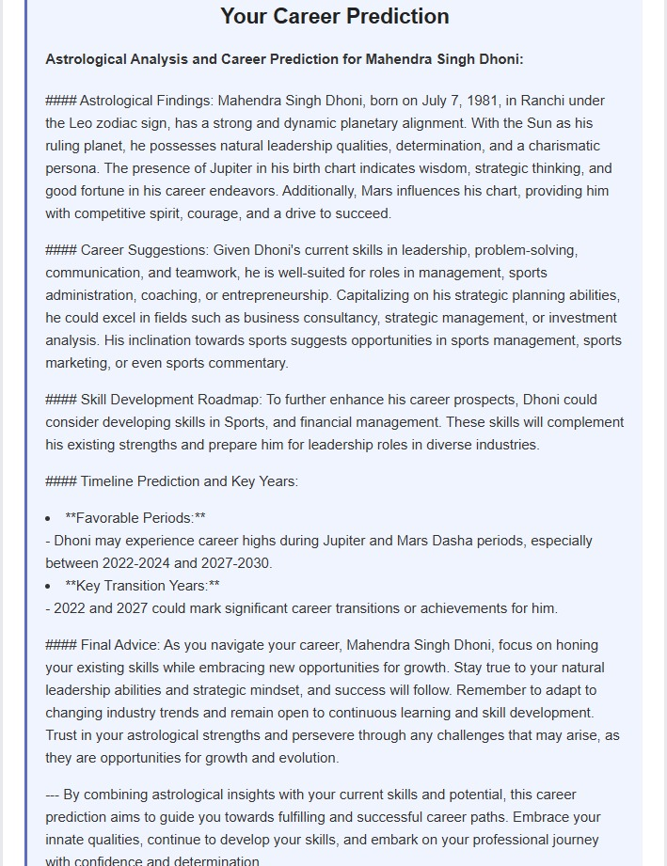

Figure 10 User Result Interface

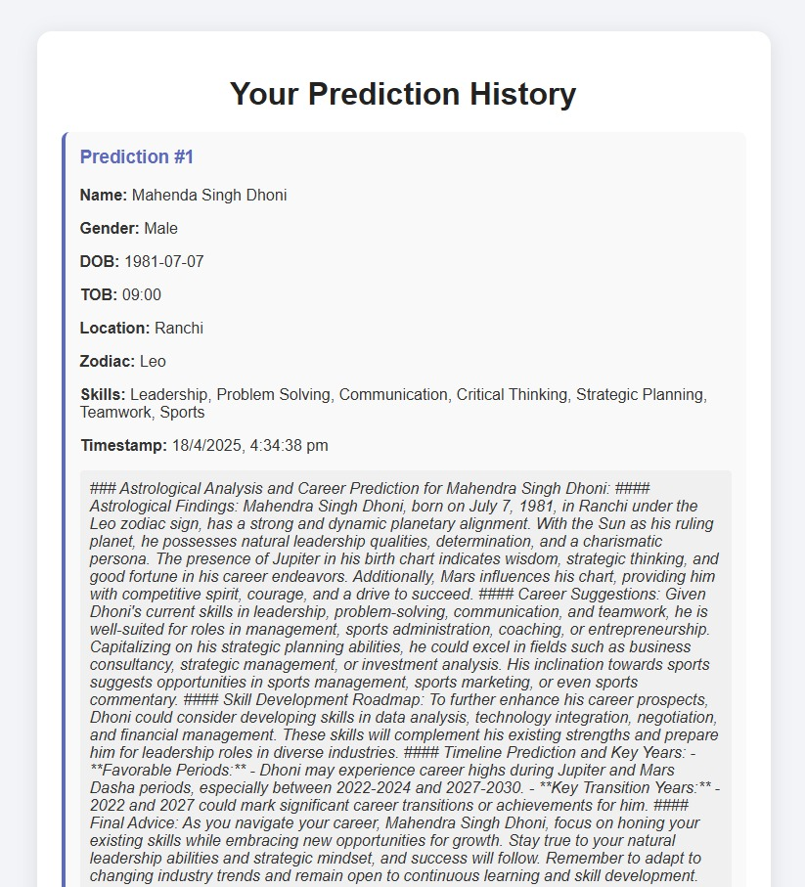

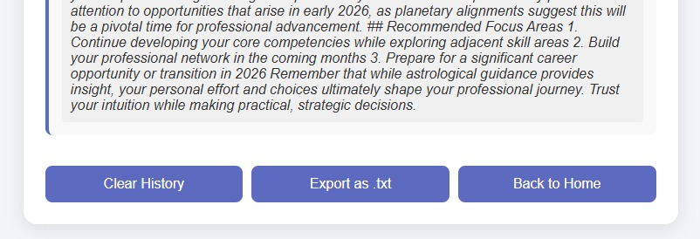

Figure 11 User History Interface

# OBSERVATIONS

During the development process, several interesting patterns and insights emerged:

* Users tend to relate well to zodiac traits, enhancing their trust in predictions.
* Fire and Air zodiac signs showed greater variation in predicted career types, indicating a potential link between zodiac classification and occupational diversity.
* The offline logic served as a fast fallback with 100% uptime, ensuring basic functionality even without internet access.
* OpenAI-generated narratives often improved user engagement due to their storytelling aspect.
* Adding more user attributes (e.g., hobbies, birth location) could drastically increase prediction depth.

During the development and testing of the model, several key observations were made. The integration of the OpenAI API significantly enhanced the quality and complexity of the generated horoscope predictions compared to the static rules of the offline mode. The ability of the LLM to generate human-like text made the online predictions feel more personalized and engaging.

The offline mode, while simple, highlighted the challenges of creating meaningful and nuanced predictions based solely on zodiac signs and a limited set of rules. It became evident that incorporating more detailed astrological data and a more sophisticated prediction logic would be necessary for more insightful offline predictions.

The user interface played a crucial role in the overall user experience. A clean and intuitive design made it easy for users The responsiveness of the OpenAI API was a factor influencing the overall performance. While generally reliable, occasional delays or variations in the generated text were observed. This highlights the importance of considering API rate limits and potential fallback mechanisms in a production environment.

The project demonstrated the feasibility of combining web technologies, basic astrological concepts, and machine learning (via an external API) for horoscope generation. However, it also underscored the limitations of the current simplified approach and the need for further development to create a more robust and astrologically sound prediction model.

# APPLICATIONS & ETHICAL CONSIDERATIONS

The Horoscope Prediction Model can be applied in various fields:

**1. Career Guidance Platforms:**

Astrology-based suggestions could serve as conversation starters or personality-based career tools.

**2. Educational Counseling:**

Students exploring career choices can use zodiac-based suggestions to identify fields that match their inherent strengths.

**3. Entertainment and Lifestyle Apps:**

Apps like Co-Star, The Pattern, and others can integrate predictive ML models for engaging user experiences.

**4. Personalized Content Recommendation:**

Astrological profiles can guide users toward articles, books, or videos tailored to their personality archetypes.

**5. AI Chatbots with Astrological Personality Modules:**

Smart assistants and mental wellness apps could use symbolic personality profiling to improve emotional resonance.

The "Horoscope Prediction Model Using Machine Learning" has several potential real-world applications, ranging from entertainment to personal development.

In the realm of entertainment, the model could be used to generate personalized horoscopes for websites, mobile apps, or social media platforms. The engaging and creative text generated by the OpenAI API could make these horoscopes more appealing to a wider audience.

For career guidance, the model could be adapted to provide insights into potential career paths based on an individual's astrological profile. While not a substitute for professional career counseling, it could offer a starting point for self-reflection and exploration.

In the area of personal development, the model could be used to provide daily or weekly affirmations and insights tailored to an individual's zodiac sign and astrological influences. This could potentially promote self-awareness and positive thinking.

Beyond these specific examples, the underlying technology could be applied to other areas where personalized text generation is desired, such as creating customized messages, generating creative content, or providing personalized recommendations.

# ADVANTAGES AND DISADVANTAGES

The "Horoscope Prediction Model Using Machine Learning" offers several advantages:

* **User-friendly interface:** The web-based interface makes it easy for users to interact with the model and receive their predictions.
* **Potential for personalized insights:** The use of the OpenAI API allows for the generation of more tailored and engaging horoscope readings compared to generic predictions.
* **Modular design:** The separation of the frontend, backend, and prediction logic allows for flexibility and scalability.
* **Dual online/offline modes:** The inclusion of both online and offline modes provides a fallback option and demonstrates different prediction generation approaches.

However, the model also has several disadvantages and limitations:

* **Reliance on external API:** The online mode depends on the availability and performance of the OpenAI API.
* **Accuracy of astrological interpretations:** The model's "accuracy" in terms of astrological validity is difficult to assess and depends on the API's understanding of astrological concepts.
* **Simplified offline mode:** The offline mode provides only basic predictions based on a limited set of rules.
* **Limited astrological data:** The current model primarily uses the zodiac sign as input, neglecting other potentially relevant astrological factors.
* **Ethical considerations:** The use of predictive models, even in the context of entertainment, raises ethical questions about potential biases and the impact on users' beliefs and decisions.

# CONCLUSION

The "Horoscope Prediction Model Using Machine Learning" project represents an initial exploration into the intriguing intersection of traditional astrological practices and modern computational techniques. By developing a web-based application with both online and offline prediction capabilities, this project has demonstrated the feasibility of automating the generation of personalized horoscope readings. The online mode, leveraging the power of the OpenAI API, showcased the potential for creating engaging and contextually rich predictions through natural language processing. The offline mode, while simplified, provided a foundational understanding of rule-based prediction logic tied to basic astrological elements.

The development process highlighted both the opportunities and the challenges inherent in this endeavor. The user-friendly interface and modular design contribute to the accessibility and potential scalability of the model. However, the reliance on an external API for sophisticated predictions and the simplified astrological logic in the offline mode underscore the need for further refinement. The subjective nature of astrological interpretation and the lack of scientifically validated causal links between celestial events and life outcomes remain significant considerations.

Despite these limitations, this project serves as a valuable stepping stone for future exploration. The insights gained from integrating web technologies, basic astrological concepts, and large language models provide a foundation for more advanced development. Future iterations could focus on incorporating richer astrological datasets, implementing sophisticated machine learning algorithms, and rigorously evaluating the model's performance through user feedback and expert astrological analysis. Ultimately, while the scientific validity of astrology remains a topic of debate, the application of machine learning offers a novel lens through which to explore and potentially reimagine this ancient practice for a modern audience.

# FUTURE SCOPE

The "Horoscope Prediction Model Using Machine Learning" has significant potential for future enhancements and development.

One key area for improvement is the integration of more detailed astrological data. This could involve calculating planetary positions, aspects, and house placements based on the user's birth date, time, and location. Incorporating these more complex astrological factors would allow for more nuanced and potentially more accurate predictions.

Another area of focus could be the implementation of more sophisticated machine learning models. Instead of relying solely on the OpenAI API, the project could explore training its own models on large datasets of astrological charts and potentially correlated life events (if such reliable datasets were available). This could involve using techniques like regression, classification, or even deep learning to identify patterns and generate predictions.

Improving the user interface could also enhance the user experience. This could involve adding features like personalized chart displays, interactive elements, and more detailed explanations of the astrological concepts used in the predictions.

Exploring different modalities of output, such as audio or video, could also expand the reach and appeal of the model.

Finally, addressing the ethical considerations surrounding predictive models is crucial. This could involve implementing safeguards to prevent misuse, providing clear disclaimers about the limitations of the model, and promoting responsible use of astrological insights.

# REFERENCES

[1] Barde, S., Tiwari, S., & Patel, B. (2023). Scientific approach of prediction for professions using machine learning classification techniques. *International Journal of Modern Education and Computer Science*, *15*(4), 30-42.

[2] Chaplot, N., Dhyani, P., & Rishi, O. P. (2017). Predictive Approach of CBR in Artificial Intelligence: A Case of Astrological Predictions About the Status of Person. In *Proceedings of International Conference on Communication and Networks: ComNet 2016* (pp. 623-633). Springer Singapore.